

**HDD**



**Name: Seagate BarraCuda - 4TB Internal HDD Storage - 5400 rpm**

**Price:** Rs. 18,500

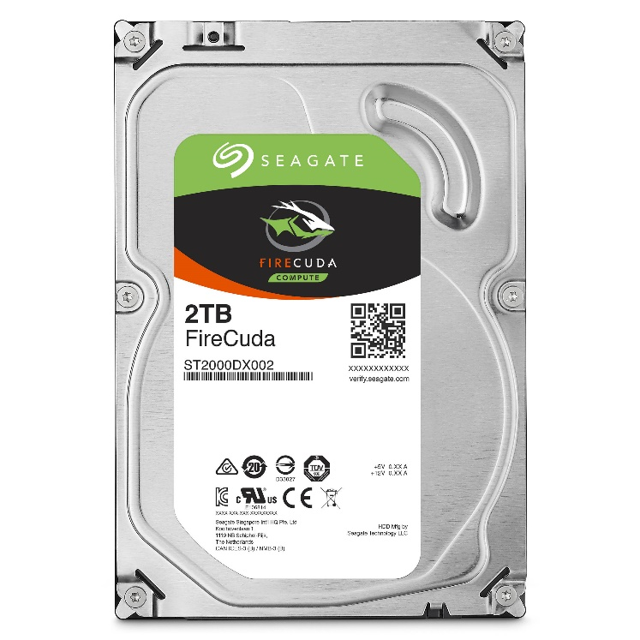**Product details of Seagate BarraCuda - 4TB Internal HDD Storage - 5400 rpm**

* Brant Warranty
* 4TB Storage Capacity
* Form Factor: 3.5"
* Spindle Speed: 5400 rpm
* Interface: SATA 6Gb/s
* Max Sustained Transfer Rate OD: 190MB/s
* Data Transfer Rate: 600MB/s
* Cache Buffer: 256MB
* Dimension: 26.1 H x 101.85 W x 146.99 D mm
* Brant Warranty
* 4TB Storage Capacity
* Form Factor: 3.5"